Petcare Rewards

Fleas, Ticks, & Heartworms

The Importance of Full-Year Tick, Flea, and Heartworm Disease Protection for Your Dog
Dr. Claire Walther
Share
Did you know that parasites are threats to your dog all year long? Despite the common belief that ticks, fleas, and mosquitoes are only active in warmer months, these pests can cause big problems for your dog at any time during the year.
They are not only a nuisance, but they can transmit diseases to your dog. The best way to protect your dog against them is year-round tick, flea, and heartworm disease protection.

Common Parasites Your Dog Encounters

Fleas
Fleas are a common parasite that bite, transmit disease, and cause your dog to itch, making them very miserable. Fleas also suck blood, and when left unchecked, this can cause lethargy, weakness, and even death if not caught and treated in time. Common (medical) conditions and infections from fleas include flea allergic dermatitis and tapeworms.
To make sure a flea infestation doesn’t begin or become a vicious cycle in your home, all your pets, including indoor-only cats or dogs, need to be on a year-round preventative. Once fleas enter your home, they can quickly take hold (each adult female flea can lay anywhere from 20–50 eggs each day)^{[1]} and cause an infestation that can be very difficult to completely get rid of.

Ticks
Ticks can be found anywhere in the United States - and at any time of the year. Like fleas, ticks suck a dog’s blood, and when left unchecked can also cause related health problems. Ticks can also transmit several debilitating diseases in dogs, such as Lyme disease, anaplasmosis, tick paralysis, and Rocky Mountain spotted fever^{[2,3,4]}.
Even when using tick preventative medications, it’s still a good idea to check your dog for ticks after time spent outside, so your dog doesn’t bring ticks indoors (and also as an additional layer of protection against disease transmission).

Mosquitoes
Mosquitoes can transmit many diseases, and just a single bite from an infected mosquito can put your dog at risk for developing heartworm disease. While dogs that spend lots of time outside (when mosquitoes are feeding) may have a higher risk, even dogs that rarely go outside are at risk for heartworm disease. In fact, cases of heartworm disease have been diagnosed in all 50 states^{[5]}.
While there are treatments available for dogs with heartworm disease, they aren’t without potential medical complications, high costs, and logistical problems (like strict crate rest for several months). Even after treatment for heartworm disease, your dog can be left with irreversible damage to the heart and lungs. Prevention is key to keep your dog from developing heartworm disease.

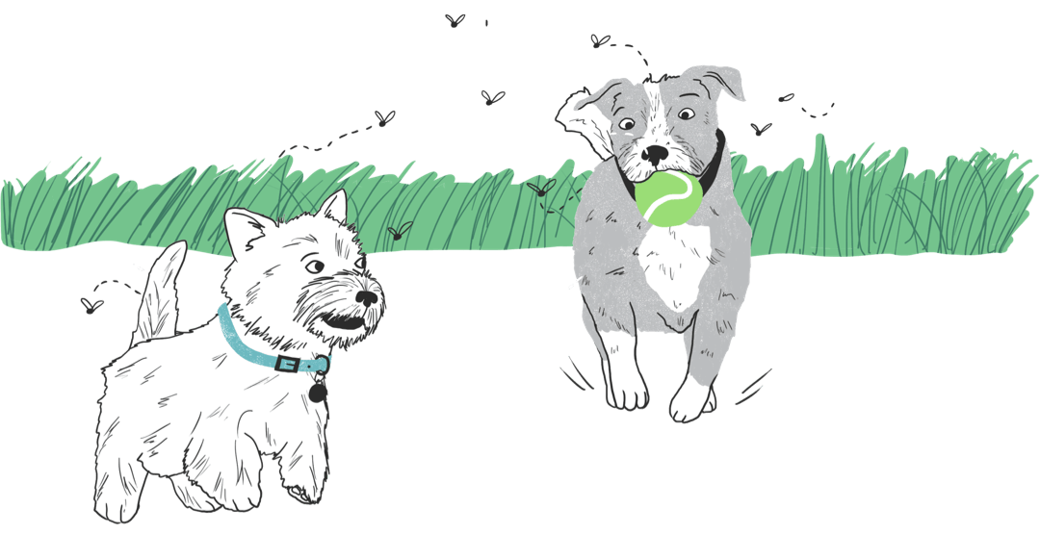

Prevention: Your Dog’s Best Form of Defense
These common parasites your dog encounters are easily prevented with products available from your veterinarian. There are chewable pills, topical solutions, and even injections that can be used to help protect your dogs. Your veterinarian should be your go-to advisor to help you figure out the products and plans that are best suited for your pets.
Prevention is a healthier, less expensive way to keep your dog healthy and safe from the many parasites they are likely to come into contact with. Keeping your pet on a full-year preventative plan will help give you peace of mind that they’re protected from parasites all year long.

